Join Us at Spirit Night  
People like you make our community a better place for our kids. We appreciate that. So tell you what – stop by and present this form at the Camden Town Center Chick-fil-A restaurant on your designated Spirit Night. Based upon the evening sales, Chick-fil-A will make donation to your school/organization. Not only will the cows win, but you will too!

**Come to Chick-fil-A at Camden Town Center and support Delaware Technology Student Association April 17th, 5-7pm**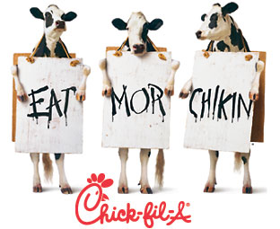

Join Us at Spirit Night  
People like you make our community a better place for our kids. We appreciate that. So tell you what – stop by and present this form at the Camden Town Center Chick-fil-A restaurant on your designated Spirit Night. Based upon the evening sales, Chick-fil-A will make donation to your school/organization. Not only will the cows win, but you will too!

**Come to Chick-fil-A at Camden Town Center and support Delaware Technology Student Association April 17th, 5-7pm**



Join Us at Spirit Night  
People like you make our community a better place for our kids. We appreciate that. So tell you what – stop by and present this form at the Camden Town Center Chick-fil-A restaurant on your designated Spirit Night. Based upon the evening sales, Chick-fil-A will make donation to your school/organization. Not only will the cows win, but you will too!

**Come to Chick-fil-A at Camden Town Center and support Delaware Technology Student Association April 17th, 5-7pm**

Join Us at Spirit Night  
People like you make our community a better place for our kids. We appreciate that. So tell you what – stop by and present this form at the Camden Town Center Chick-fil-A restaurant on your designated Spirit Night. Based upon the evening sales, Chick-fil-A will make donation to your school/organization. Not only will the cows win, but you will too!

**Come to Chick-fil-A at Camden Town Center and support Delaware Technology Student Association April 17th, 5-7pm**