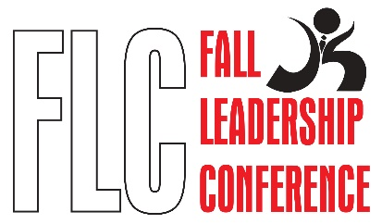
Delaware Fall Leadership Conference
November 4th and 5th, 2020

Objective: To provide a series of interactive sessions emphasizing organizational teamwork, leadership, and steps to create positive impact with self and community.

9:00am-9:30am - Welcome and introduction of CTSO State Officers

9:30-10:15 Navigating Unconscious Bias - Everyone has bias. They are neither positive nor negative; in fact, they are neutral. However, when we remain unaware of the judgements our brain is making for us, our unconscious biases can become our conscious behaviors. In this talk, we break down the human brain’s need for creating bias and what we can do to navigate those biases so we can avoid making wrong assumptions and misperceptions, and instead speak and act in ways that allow us to see, hear, and accept people for who they are. Through the use of personal storytelling, funny anecdotes, and challenging the audience with moments of reflection, this session will have participants leaving with a new sense of self-awareness and desire to navigate their own unconscious bias.

10:15am-11:00am Break

11:00am-12:00pm Team Communication - Oftentimes when teams are forming and are challenged with accomplishing a task, their biggest hurdles they face can be attributed to something so simple yet so complex: communication. A team’s ability to listen, to understand, to effectively say what needs to be said can prove to be the singular pillar that helps the team even begin to accomplish their tasks. In this session, we use the skills and methods found in improvisational comedy to break down ways to listen, talk, and work together to not only strengthen communication but to also strengthen a team’s dynamic.

12:45pm-1:30pm - Communicating Virtually - Although many of us are faced with the challenges of working remotely, we are also able to leverage technology in new and useful ways. From audio control to visual aesthetics, communicating virtually requires users to focus on the small details that allow viewers to seamlessly interact with them through digital means. This session will focus on techniques used to improve audio, visual, and workspace logistics in order to create the best virtual environment when communicating.

1:30-2:00 Break

2:00pm-3:00 - From Self-Awareness to Self-Management - The typical predictor of success has always been one’s intellectual quotient or IQ; however, research has shown that a person’s ability to be aware of, control, and express one’s emotions with a higher capacity can help them strengthen their relationships and the way in which they are perceived. Learning and leveraging Emotional Intelligence, otherwise known as EQ, can help lead individuals to personal and professional success as it helps them understand their emotions, control them, and ultimately make decisions that level rational thinking rather than immediate.

3:00-3:15 Closing-CTSO Officer

